Bureau of Safety and Environmental Enforcement

Oil Spill Preparedness Division

Project Title
Volume Number: Subtitle

Draft Report, Final Report

Month Year
INSTRUCTIONS AVAILABLE
This document is provided as a template only. Additional information and guidance on how to prepare OSPD reports are available in the OSPD Report Specifications.
(Photo: Organization, Year)

Author One’s Name, Author Two’s Name, Author Three’s Name, etc. Note: Author’s names should appear in the order in which they are presented on the original report, not necessarily in alphabetical order.

Project Title
Volume Number: Subtitle(Optional)

Draft Report, Final Report
OSRR # 0000
© YYYY Copyright holder (Optional)
Month Year
Authors:
Name of Author #1
Organization of Author #1

Name of Author #2
Organization of Author #2

Prepared under Contract or Agreement Number
By
Organization Name
Organization address

DISCLAIMER
[Select the correct disclaimer statement from below based on the type of award, filling in the appropriate text and numbers where indicated.]

Contracts:
Study concept, oversight, and funding were provided by the US Department of the Interior (DOI), Bureau of Safety and Environmental Enforcement (BSEE), Oil Spill Preparedness Division (OSPD), Sterling, VA, under Contract Number X00XX00000. This report has been technically reviewed by BSEE, and it has been approved for publication. The views and conclusions contained in this document are those of the authors and should not be interpreted as representing the opinions or policies of the US Government, nor does mention of trade names or commercial products constitute endorsement or recommendation for use.

Interagency and Intra-Agency Agreements (select “Interagency” for agreements with Agencies outside of the US Department of the Interior (DOI) or “Intra-Agency” for Agencies within DOI):
This study was funded, in part, by the US Department of the Interior, Bureau of Safety and Environmental Enforcement (BSEE), Oil Spill Preparedness (OSPD), Sterling, VA, through [Interagency or Intra-Agency] Agreement Number Agreement Number with the Agency. This report has been technically reviewed by BSEE, and it has been approved for publication. The views and conclusions contained in this document are those of the authors and should not be interpreted as representing the opinions or policies of the US Government, nor does mention of trade names or commercial products constitute endorsement or recommendation for use.

Cooperative Agreements:
Study collaboration and funding were provided by the US Department of the Interior (DOI), Bureau of Safety and Environmental Enforcement (BSEE), Oil Spill Preparedness (OSPD), Sterling, VA, under Agreement Number Agreement Number. This report has been technically reviewed by BSEE, and it has been approved for publication. The views and conclusions contained in this document are those of the authors and should not be interpreted as representing the opinions or policies of the US Government, nor does mention of trade names or commercial products constitute endorsement or recommendation for use.

REPORT AVAILABILITY
[Enter the OSRR project number provided by the COR under the first source and the project title under the Search Term column for the second and third sources. If available, list other sources for the report and the associated information.]

The PDF file for this report is available through the following sources. Click on the URL and enter the appropriate search term to locate the PDF:

Document Source | Search Term | URL
Bureau of Safety and Environmental Enforcement (BSEE) | Project Number – XXXX | https://www.bsee.gov/what-we-do/research/oil-spill-preparedness/oil-spill-response-research
U.S. Department of the Interior Library | Project Title | https://library.doi.gov/uhtbin/cgisirsi/?ps=8L0mpW5uPV/SIRSI/X/60/495/X
National Technical Reports Library | Project Title | https://ntrl.ntis.gov/NTRL/
Sources: a) BSEE (2019), b) DOI [2021], c) National Technical Information Service (2021)

CITATION
Lastname IN, Lastname IN, Lastname IN (Contractor name, City ST). Year. Report title in sentence caps. City (ST): U.S. Department of the Interior, Bureau of Safety and Environmental Enforcement. xx p. Report No.: xxxx Contract No.: xxxxx.

ABOUT THE COVER
Optional: Cover image by Photographer/Organization. Insert additional details about the cover image here.

ACKNOWLEDGEMENTS
Optional: Include acknowledgements or remove this section Copyright authorization should be included here, if applicable.

GRAPHICAL ABSTRACT
[A Graphical Abstract is required. Insert a single, concise, pictorial and visual summary of the project’s main [significant] findings. The Graphical Abstract should capture the content of the project report for readers at a single glance. See an example published Graphical Abstract below. The Graphical Abstract should be followed by a page break.

Graphical Abstract Image size: Include an image with a minimum of 531 × 1328 pixels (h × w) using a minimum resolution of 300 ppi, highest resolution possible is preferred. The image should be scaled proportionally to fit within the page margins. Check the resolution details of your image by saving the image on your computer. Right click on the File> Properties> Details> Image.

No additional text, outline or synopsis should be included for the Graphical Abstract. However, for Section 508 compliance, provide an “alt text” description for the Graphical Abstract that provides a brief description of what is shown. Right click on the image and select “Edit Alt Text” to add a description. Text within a graphical abstract must meet color contrast standards. Standard text less than 12 pt regular must have a contrast ratio of 4.5 :1. Large text (14 pt bold or 18 pt regular) must have a contrast ratio of 3:1.

Example Reference: Elsevier Science Authors Instructions: https://www.elsevier.com/authors/journal-authors/graphical-abstract]

EXECUTIVE SUMMARY
Insert an Executive Summary about the study. The Executive Summary should be concise and, written in plain language, and provide an overview about the research in approximately 500-1,000 words. The summary should be followed by a page break.

Contents
List of Figures ii
List of Tables ii
1 Heading 1 Style 3
1.1 Heading 2 Style 3
1.1.1 Heading 3 Style 3
2 Notes 6
3 References 7
Appendixes 8
4 Abbreviations and Acronyms 12

List of Figures
Fig. 1 P16400 Marco skimmer 2
Fig. 2 MC 252 Target aromatics 3
Fig. 3 Figure caption 3

List of Tables
Table 1 Sample table with heading style 1
Table 2 Sample table in landscape orientation with data in columns aligned on the decimal (units) 9

Heading 1 Style
Do not modify the style definitions in this template. Add a new style only if necessary. Heading styles are set to “Keep with next” to keep the heading with the first two lines of the subsequent paragraph to avoid page breaks between heading and text. “Widow/Orphan control” should be kept on throughout the document to avoid awkward line breaks. Each section should be followed by a section break. Subsections do not need to be followed by a section break.

Heading 2 Style
This is the Normal style. Heading styles in this template are all followed by the Normal style in the next paragraph. Spacing between headings and paragraphs is already set.

Heading 3 Style
See a sample table in Table 1. Use the Table Title style to automatically include the table title in the List of Tables. Table Column Head style is formatted for the column headers, and table text styles come in two sizes: Table Text (10 pt) and Table Text Smaller (9 pt).

To align the numbers in a column on the decimal as shown in the fourth column of Table 1.
- Use the “Table Cell (left)” style
- Select the cells you want to align
- Double click on the lower part of the ruler around the place you want to put the decimal (or go to Paragraph > Tabs and enter an amount for the distance of the decimal from the left cell margin)
- Select “Decimal,” “Set,” and “OK.”

Table 1 Sample table with heading style
Column header 1 (left-aligned) | Column header 2(left-aligned) | Column header 3 (left-aligned) | Column header 4 (left-aligned)
Row 1 |  |  | 0.33
Row 2 |  |  | 65.21
Row 3 |  |  | 452.398

Heading 4 Style
Use Headings 1–6 for the main body of the report. Headings 1–3 are listed in the Contents.
Use Headings 7–9 for the appendix or appendixes. Heading 7 is listed in the Contents. Headings 8 and 9 may be used if needed.

Heading 5 Style
- List paragraph style automatically selected for bullets and ordered lists
List paragraph style automatically selected for bullets and ordered lists
  - List paragraph style automatically selected for bullets and ordered lists
    - List paragraph style automatically selected for bullets and ordered lists
- Use the Numbered List style for numbered lists.
- Use the Numbered List style for numbered lists.
  - Use the Numbered List style for numbered lists.
    - Use the Numbered List style for numbered lists.

Heading 6 Style
Refer to Figure 1 below for an example of the figure style. Use the caption style (Arial 10 pt bold) to include a short caption. Figure Notes style (Arial 9pt) is may be used to include additional information about the figure.

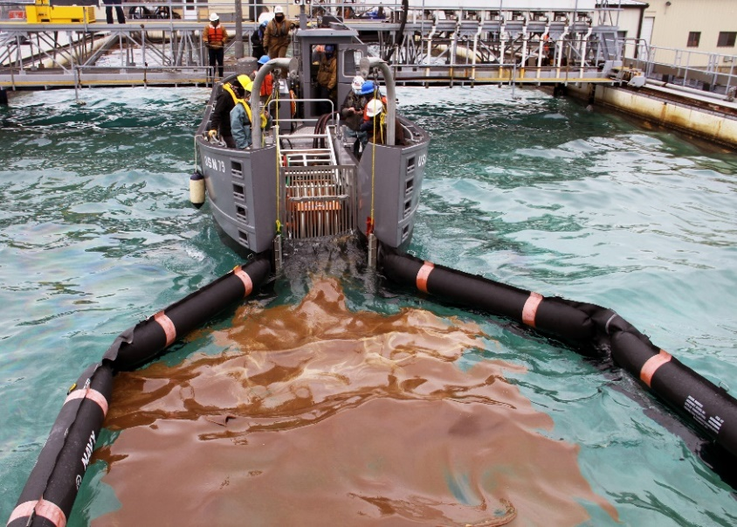
Fig. 1 P16400 Marco skimmer
A combined team of personnel from Navy SUPSALV and Global PCCI measure the capabilities of P16400 Marco Class V Skimmer Vessel equipped with an Elastec Grooved X-Disc at Ohmsett (Photo: BSEE, 2021)
Fig. 2 MC 252 Target aromatics
Target analyte profiles for aromatics in fresh MC2552 source oil (riser fluid) (Shigenaka, 2015)

Fig. 3 Figure caption style
Insert additional notes about figure using the Figure Notes style. Add alternative text to the figure if the figure caption and notes do not include enough detail about what is shown. (Photo: Organization ,Year.)

For photo credit, use the following format: (Photo: [Organization], [Year])

Notes
Optional: Insert endnotes, if needed.

References
Required. Use an author-date system for references. The example below is the recommended Scientific Style and Format: The CSE Manual for Authors, Editors, and Publishers 8th Edition (CSE 2014) format. For an online list of citation format examples in this format, see the Scientific Style and Format Citation Quick Guide (CSE 2014)

[CSE] Council of Science Editors. 2014. Scientific Style and format: the CSE manual for authors, editors, and publishers. 8th ed. Chicago (IL). University of Chicago Press. 722p.

CSE. c2014. Scientific style and format citation quick guide. Chicago (IL0. University of Chicago Press; [accessed 2021 Feb 02] http://scientifictstyleandformat.org/Tools/SSF-Citation-Quick-Guide.html.

Kaminskasa l. Porter C.J.H. 2011. Targeting the lymphatics using dendritic polymers (dendrimers). Advanced Drug Delivery Reviews, 63:10-11. [accessed 2021 Apr 07] http://dx.doi.org/10.1016/j.addr.2011.05.016

National Technical Information Service. C2014. National Technical Reports Library. National Technical Information Service; [accessed 2021 Feb 02]. https://ntrl.ntis.gov/NTRL/

Shigenaka G, Overton E, Meyer B. Gao H, Miles S. 2015. Comparison of Physical and Chemical Characteristics of in situ burn residue and other environmental oil samples collected during the Deepwater Horizon spill responses. Seattle (WA). US Department of the Interior, Bureau of Safety and Environmental Enforcement. Figure 11. Target analyte profiles for n-alkanes and aromatics in fresh MC252 source oil (riser fluid) p. 20.

US Government Publishing Office. [date unknown]. Welcome to the Federal Depository Library Directory (FDLD). Washington (DC): US Government Publishing Office; [accessed 2017 May 15]. https://catalog.gpo.gov/fdlpdir/FDLPdir.jsp.

Appendixes

Appendix A: Technical Summary
REPORT TITLE: Insert Report Title
CONTRACT NUMBER(S): X00XX00000
FISCAL YEARS(S) OF PROJECT FUNDING: FY20XX
CUMULATIVE PROJECT COST: $000,000
COMPLETION DATE OF REPORT: DD Month YYYY
BSEE COR(S): BSEE COR’s name
BSEE CO(S): BSEE CO’s name
PROJECT MANAGER(S):Project Manager’s Name(s)
AFFILIATION OF PROJECT MANAGER: Organization Name
ADDRESS: Street Address, City, State ZIP code
PRINCIPAL INVESTIGATOR(S)*: Principal Investigator(s) Name
KEY WORDS: Include key words that describe the project

* The affiliation of the Principal Investigators(s) may be different than that listed for Project Manager(s).

Appendix B: Heading Style 7

Heading Style 8
Optional elements include any additional information, data, or exhibits that support or amplify text contained in the report. These elements could include tables, figures, maps, text, etc.

Heading 9 Style
Normal style

Appendix C: Sample Table in Landscape Orientation
Table 2 Sample table in landscape orientation with data in columns aligned on the decimal (units)
Row Header | Column Header 1 | Column Header 2 | Column Header 3 | Column Header 4 | Column Header 5 | Column Header 6
Row 1 | 0.00 | 0.00 | 0.00 | 0.00 | 0.00 | 0.00
Row 2 | 0.00 | 0.00 | 0.00 | 0.00 | 0.00 | 0.00
Row 3 | 00.00 | 00.00 | 00.00 | 00.00 | 00.00 | 00.00
Row 4 | 00.00 | 00.00 | 00.00 | 00.00 | 00.00 | 00.00
Row 5 | 000.00 | 000.00 | 000.00 | 000.00 | 000.00 | 000.00
Row 6 | 0.00 | 0.00 | 0.00 | 0.00 | 0.00 | 0.00

Abbreviations and Acronyms
[Short Form] | [Long Form]
AUV | Autonomous Unmanned Vehicle
BSEE | Bureau of Safety and Environmental Enforcement
CO | Contracting Officer.
COR | Contracting Officer’s Representative
CSE | Council of Science Editors
DM | Departmental Manual
DOI | Department of the Interior
NRS | National Response System
NRTL | National Technical Reports Library
OSPD | Oil Spill Preparedness Division
OSRR. | Oil Spill Response Research
ppi | Pixel Per Inch
PV | Preparedness Verification
Template | Oil Spill Preparedness Division Report Template

Department of the Interior (DOI)
The Department of the Interior protects and manages the Nation's natural resources and cultural heritage; provides scientific and other information about those resources; and honors the Nation’s trust responsibilities or special commitments to American Indians, Alaska Natives, and affiliated island communities.
Bureau of Safety and Environmental Enforcement (BSEE)
The mission of the Bureau of Safety and Environmental Enforcement works to promote safety, protect the environment, and conserve resources offshore through vigorous regulatory oversight and enforcement.
BSEE Oil Spill Preparedness Program
BSEE administers a robust Oil Spill Preparedness Program through its Oil Spill Preparedness Division (OSPD) to ensure owners and operators of offshore facilities are ready to mitigate and respond to substantial threats of actual oil spills that may result from their activities. The Program draws its mandate and purpose from the Federal Water Pollution Control Act of October 18, 1972, as amended, and the Oil Pollution Act of 1990 (October 18, 1991). It is framed by the regulations in 30 CFR Part 254 – Oil Spill Response Requirements for Facilities Located Seaward of the Coastline, and 40 CFR Part 300 – National Oil and Hazardous Substances Pollution Contingency Plan. Acknowledging these authorities and their associated responsibilities, BSEE established the program with three primary and interdependent roles:
- Preparedness Verification,
- Oil Spill Response Research, and
- Management of Ohmsett - the National Oil Spill Response Research and Renewable Energy Test Facility.

The research conducted for this Program aims to improve oil spill response and preparedness by advancing the state of the science and the technologies needed for these emergencies. The research supports the Bureau’s needs while ensuring the highest level of scientific integrity by adhering to BSEE’s peer review protocols. The proposal, selection, research, review, collaboration, production, and dissemination of OSPD’s technical reports and studies follows the appropriate requirements and guidance such as the Federal Acquisition Regulation and the Department of Interior’s policies on scientific and scholarly conduct.

